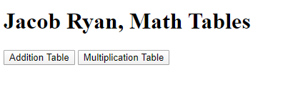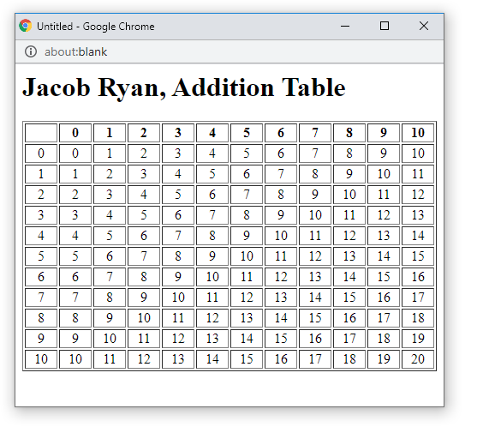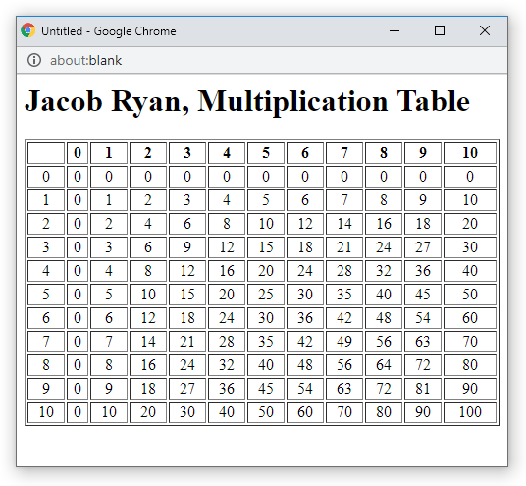

<!doctype html>

<html>

<head>

<!--

CIS213 Unit 3, Graded Exercise 2

Author: Jacob Ryan

Date 1/6/2020

-->

</head>

<body>

<h1>Jacob Ryan, Math Tables</h1>

<button onclick="additionTable()">Addition Table</button>

<button onclick="multiplicationTable()">Multiplication Table</button>

</body>

<script>

"use strict"

function additionTable()

{

var tableWin = window.open("", "MathTableDisplay",

"toolbar=no,menubar=no, location=no, scrollbar=yes, resizable=no, width=500, height=400");

tableWin.document.open();

tableWin.document.write("<h1>Jacob Ryan, Addition Table</h1>");

tableWin.document.write("<table border='1' width='100%'>");

//creat the top header row

tableWin.document.write("<tr><th>&nbsp;</th>");

for (var i = 0; i < 11; i++)

{

tableWin.document.write("<th>" + i + "</th>");

}

tableWin.document.write("</tr>");

//create the row headers and the solutions

for (var i = 0; i < 11; i++)

{

tableWin.document.write("<tr align='center'><td>" + i + "</td>");

for (var j = 0; j < 11; j++)

{

tableWin.document.write("<td>" + (i + j) + "</td>");

}

tableWin.document.write("</tr>");

}

tablewin.document.write("</table>");

tablewin.document.close();

tablewin.focus();

}

function multiplicationTable()

{

var tableWin = window.open("", "MathTableDisplay",

"toolbar=no,menubar=no, location=no, scrollbar=yes, resizable=no, width=500, height=400");

tableWin.document.open();

tableWin.document.write("<h1>Jacob Ryan, Multiplication Table</h1>");

tableWin.document.write("<table border='1' width='100%'>");

//creat the top header row

tableWin.document.write("<tr><th>&nbsp;</th>");

for (var i = 0; i < 11; i++)

{

tableWin.document.write("<th>" + i + "</th>");

}

tableWin.document.write("</tr>");

//create the row headers and the solutions

for (var i = 0; i < 11; i++)

{

tableWin.document.write("<tr align='center'><td>" + i + "</td>");

for (var j = 0; j < 11; j++)

{

tableWin.document.write("<td>" + (i \* j) + "</td>");

}

tableWin.document.write("</tr>");

}

tablewin.document.write("</table>");

tablewin.document.close();

tablewin.focus();

}

</script>

</html>